Report:

Through the data given, we have came up with 2 groups:

Group 1: Neutral liking Group

Includes:

* Jamie
* Julie
* Jo
* Jasmine
* Jane

Group 2: Food lovers Group

Includes:

* Jennifer
* Jenny

To appeal and market to group 1, show them ads for both broccoli and snickers that specifically present them both in a new way or try to make them look more appetizing. This group may need a different perspective on these foods as they tend to not show a high liking for either option.

To appeal and market to group 2, Show them general ads for both broccoli and snickers as they show a high liking for both.

K-Means Clustering :

Iteration 1:

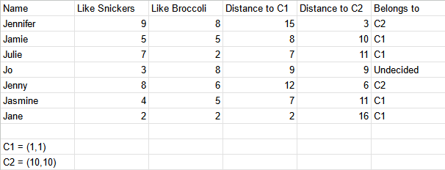

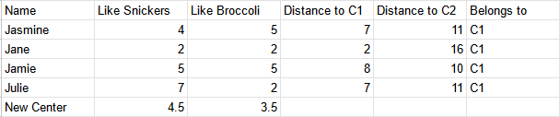

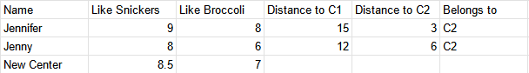

Iteration 2:

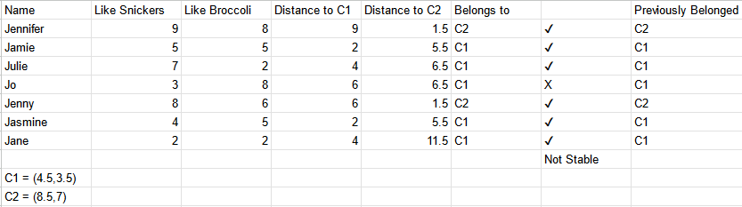

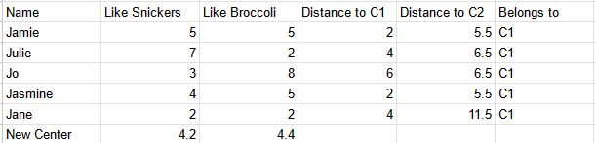

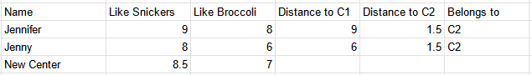

Iteration 3:

